Modeling Cloud Behaviour   
using Multi-Variable CD++

Michael Lepard

Dept. of Systems and Computer Engineering  
Carleton University  
1125 Colonel By Drive  
Ottawa, ON. K1S-5B6 Canada

mlepard@connect.carleton.ca

**ABSTRACT**

This paper presents a model for generating cloud behavior using cellular automaton based on work done by Dobashi(1998)[1]. Multiple state variables for each cell are used to represent transformation from water vapor to clouds and then the extinction of clouds. The behavior of these state variables is controlled through use of random distributions to ensure the system always evolves.

The model was implemented using a version of CD++, a DEVS simulator[2], that supports the definition of state variables for a cellular automaton. Following the implementation of the single variable CD++ model[3] in the multi-variable version the model was extended to include inputs that could affect the probability distributions that control the generation and extinction of cloud as well as the simulation of wind to move the presence of clouds around within the cell space.

# INTRODUCTION

The generation of clouds in visual systems for real-time simulators is challenging. The current approach is to use static billboard images that do not evolve over time. Previous work [1] has been done to model cloud behavior using cellular automaton. This work introduced a basic set of state variables and transition rules to generate cloud behavior based on the state of the cellular neighborhood.

This proposed cellular automaton was modeled using CD++[2], a DEVS based simulator that provides a framework and language for developing cellular automaton models. By default the DEVS cellular automaton model only contains a single variable for each cell. This cloud generation model was first implemented [3] using the single variable implementation of CD++. In this paper an improved version of CD++, which supports the definition of multiple state variables in a cellular automaton, was used to generate the multi-variable model and to expand upon the original work.

To take advantage of the multi-variable capabilities of CD++ and to expand upon the basic cellular automaton model proposed [1] two new capabilities were added to the model: the ability to use input events to control the evolution of the system and the addition of wind to move the presence of clouds through the cell neighborhood.

The proposed cloud generation model is a continuously evolving system that is controlled using probability distributions that determine when some state variable change state to affect the system. This behavior is encoded in the transition rules within the model and CD++ does not provide a simple method to control these probability distributions. In previous work [3] these distributions were controlled by creating different transition rules to define different behaviors. This was a complicated method that did not provide for a lot of flexibility.

A method for controlling the distribution using inputs defined in the models CD++ event file was added to the model. Additional state variables that control the characteristics of the probability distribution for that cell were added. The input changes the distribution state variables and is also sent to the cell neighbors so that a diffusion of the new distribution values can occur.

To further complicate the multi-variable model and to improve the realism of the cloud behavior the concept of wind was added to the model. Two constant state variables were added to the cell for wind, one for the north direction and one for the east direction. The transition rules were then modified such that when a cloud is present in the cell and these variables do not equal zero the cloud is blown into an adjacent cell.

The behavior of these cloud generation models were tested individually and then evaluated using subject methods. The performance of the multi-variable against the single variable CD++ was also evaluated using the basic cloud generation model.

# BACKGROUND

For the models developed in this paper the basic behavior of clouds is controlled by four state variables: hum, cld, act and ext. These variables represent vapor, clouds, phase change from vapor to clouds and the process of cloud extinction. Dobashi [1] defines a three dimensional neighborhood and provides four simple functions for calculating the state of each variable in the cell, based on the variables of cells within its neighborhood.

)

Thus to generate a cloud a cell must first have water vapor present, represented by *hum*. If the water vapor is present it enters the transformation stage, *act*, if other water vapor in its neighborhood is already in the process of changing. A cloud is the present, *cld*, after the transformation process and remains present until it is extinguished. To enter the extinction phase, *ext*, the cell must first have clouds present and another cell in its neighborhood is already in the extinction process. Once the extinction process is complete, *ext* is true; the cloud is removed from the cell.

Based on these transition rules the evolution of the cloud system can be controlled through the *hum, act,* and *ext* state variables. Dobashi [1] recommends a process of using random distribution to assign true values to the variables. The method of controlling these distributions and the location within the neighborhood they are used can be used to simulate complicated cloud behavior.

## CD++ Implementation

The CD++ software provides a programming language to implement cell transition rules. However, the original CD++ version used [2] only provides a single value for each cell. To model multi-variable systems, as in the cloud generation model defined above, several different approaches can be used. To implement the cloud generation system a 2D plane was defined for each state variable. This approach required the cell neighborhood to be reduced to two dimensions.

To handle the random generation of state variables an additional term was added to each transition rule that contained a probability distribution. If the other conditions failed but the normal probability distribution returned a value greater than 0.5 the variable became true.

Three methods were investigated for controlling the cloud generation system using these distributions. The first was a normal distribution that had the same average and deviation values across all cells for each state variable. The second was to create zones within the cell space that had transitions functions with different average and deviation values. The final method was an expansion on the zone method that modified the average and deviation values over time.

These methods were not easy to implement or modify and required extensive modifications to the transition functions to obtain different behavior.

An updated CD++ software was obtained that allows the definition of multiple variables for each cell. The addition of multiple variables will allow the existing model to be expanded to provide additional functionality. The transition functions have been expanded to allow for both the assigning of new values to the internal state variables and for sending the state variables to input ports on the neighboring cells. The transition function is broken into four components:

{port_assignations} [ {assignations} ] {delay} {condition}

Output ports are assigned using in port_assignations:

~variable_port ≔ value;

The default output port can still be assigned using either ~out or (0,0). Assigning state variables is optional and is done in assignations:

$variable ≔ value;

In both of these cases the value can be the result of any function that returns a value. It should be noted that with the internal value of state variables and the variables sent on the output port can now be different.

With the introduction of multiple variables into CD++ the τ(N) function used in the Cell-DEVS formal specification to define the output value of the transition function must be expanded to reflect both the internal variable transition and the value sent to the output port.

# MODELS

Three models based on the cloud generation system described above were implemented in the multi-variable CD++ software. The first model was a basic implementation of the cloud generation system. This model was used to validate the performance of the multi-variable CD++ against the single variable version. The second model implemented the ability to control the distribution parameters for the system from the CD++ input event file. The final model added the concept of wind to the system and enabled existing clouds to move around the cell space.

## Basic Multi-Variable

A basic version of the cloud generation rules was implemented using the multi-variable CD++. *Act*, *hum*, and *ext* where represented using state variables with a value of 0 or 1. The presence of clouds, *cld*, was indicated by the value of the cell, 0 represented no clouds while 10 indicated the presence of clouds.

Three transition rules were all that was required to define the behavior of the system:

[cloud-gen]

rule : { ~out := 10; ~ext := $ext; ~act := $act; }

{ $hum := #macro(hum-change);

$ext := #macro(ext-change);

$act := #macro(act-change);}

100 {$ext = 0 AND ((0,0) = 10 OR $act = 1)}

rule : { ~out := 0; ~ext := $ext; ~act := $act; }

{ $hum := #macro(hum-change);

$ext := #macro(ext-change);

$act := #macro(act-change);}

500 {$ext = 1 AND (0,0) = 10}

rule : { ~out := 0; ~ext := $ext; ~act := $act; }

{ $hum := #macro(hum-change);

$ext := #macro(ext-change);

$act := #macro(act-change);}

100 {t}

Figure - Basic Transition Rules

The macros *hum-change*, *act-change*, *ext-change* implement the transition rules for each state variable combined with the distribution used to evolve the system. An example macro is provided below:

if( ( $act = 0 AND $hum = 1 AND

( (1,0)~act = 1 OR (-1,0)~act = 1 OR

(0,1)~act = 1 OR (0,-1)~act = 1 OR

(2,0)~act = 1 OR (-2,0)~act = 1 OR

(0,2)~act = 1 OR (0,-2)~act = 1 ) )

OR normal(0.5,0.1) > 0.5, 1, 0)

Figure - Example Basic Macro

The basic model uses a constant normal distribution that is applied uniformly to all cells in the neighborhood. To adjust the behavior of the cellular automaton the average and standard deviation values are different for each state variable.

### Formal DEVS Specification

The formal atomic cellular automaton model is defined as:

δ , δ , λ, and ta are deined using Cell-DEVS specications.

For the basic cloud generation model τ(N) reflects the internal value of the state variables.

Table - Basic Transition Functions

|  |  |  |
| --- | --- | --- |
| **State** | **τ(N)** | **N** |
| Ext | 1 | $ext = 0 AND (0,0) = 10 AND  ( (1,0)~ext = 1 OR (-1,0)~ext = 1 OR  (0,1)~ext = 1 OR (0,-1)~ext = 1 OR  (2,0)~ext = 1 OR (-2,0)~ext = 1 OR  (0,2)~ext = 1 OR (0,-2)~ext = 1 )  OR normal(0.5,0.1) > 0.5 |
| Hum | 1 | ($hum = 1 AND $act = 0) OR normal(0.5,0.1) |
| Act | 1 | $act = 0 AND $hum = 1 AND  ( (1,0)~act = 1 OR (-1,0)~act = 1 OR  (0,1)~act = 1 OR (0,-1)~act = 1 OR  (2,0)~act = 1 OR (-2,0)~act = 1 OR   (0,2)~act = 1 OR (0,-2)~act = 1 )  OR normal(0.5,0.1) > 0.5 |
| Cld | 10 | $ext = 0 AND ((0,0) = 10 OR $act = 1) |
| Cld | 0 | $ext = 1 AND (0,0) = 10 |
| All | 0 | true |

The coupled model used for this basic mode has no inputs or ouputs and is defined as:

C = is the cell space set, defined above.

Z is defined as with a Pi,j for each state variables:

Pi,jY1 🡪 Pi,j-1X1 Pi,j+1Y1 🡪 Pi,jX1

Pi,jY2 🡪 Pi,j-2X2 Pi,j+1Y2 🡪 Pi,jX2

Pi,jY3 🡪 Pi,j+1X3 Pi,j-1Y3🡪 Pi,jX3

Pi,jY4 🡪 Pi,j+2X4 Pi,j-2Y4 🡪 Pi,jX4

Pi,jY5 🡪 Pi-1,jX5 Pi+1,jY5🡪 Pi,jX5

Pi,jY6 🡪 Pi-2,jX6 Pi+2,jY6 🡪 Pi,jX6

Pi,jY7 🡪 Pi+1,jX7 Pi-1,jY7 🡪 Pi,jX7

Pi,jY8 🡪 Pi+2,jX8 Pi-2,jY8 🡪 Pi,jX8

select = { (0,0), (-2,0), (-1,0), (1,0), (2,0),

(0,-2), (0,-1), (0,1), (0,2) };

The final simulation model consisted of only one coupled model, defined above, with no inputs or outputs to the system.

This model was verified to be functionally correct and evaluated against the original single variable CD++ model for both behavior and speed of execution.

## Improved Distribution Model

The basic cloud generation model did not provide any method to control the evolution of the system. The parameters of the distribution used to control generation of state variables were fixed and did not evolve over time. To implement a method of controlling the distribution two state variables were added: *avggen* and *avgext*. These variables were used as the average parameter passed into the normal distribution: *avggen* was used for *act-change* and *hum-change* to control the generation of clouds while *avgext* was used for *ext-change* to control the extinction of clouds.

Several inputs where then added to the atomic model, these inputs are used to specify the *avggen* and *avgext* value for the cells they are connected to. Because CD++ does not allow a single input to be linked to a group of cells the concept of diffusing the new average state variables was implemented. A change in the average state variables within a cell is sent to the neighboring cells and they update their average state variables based on the distance from the input cell.

The transition functions defined previously were expanded to accommodate this new behavior. Two new macros were defined to update the average values, *avggen-change* and *avgext-change*. An example macro is provided in figure 3 where the first layer of cells around the input cell will have an *avgext* value of 100% the input value, the second layer of cells will have 90% and the third layer will have 80% the value.

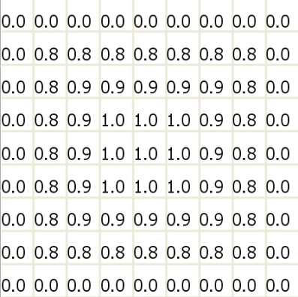

Figure - Input Average Diffusion

Figure 3 shows the resulting internal average values following an input at (4,4) of 1.0. The details of the internal calculations are provided in table 2.

The model also defines two additional transition functions that are used when an input is provided to the specified cell: *set-average-gen* and *set-average-ext*. These port-in transition functions, combined with manipulating the output *avggen* and *avgext* variables ensure the average state variable information is diffused correctly.

Figure - Distribution Transition Functions

[set-average-gen]

~avggen := portValue(thisPort);

$avggen := $avggen + portValue(thisPort); $avgext := #macro(avgext-change);

[cloud-gen]

~avggen := 0; ~avgext := 0;

$hum := #macro(hum-change);

$ext := #macro(ext-change);

Figure 4 provides the components of the new transition functions that update the various average distribution variables. The process by which these variables are updated when an input occurs is as follows:

1. The set-average-gen or set-average-ext port-in transition function is called when an input occurs.
2. The cells internal state variable is added to the new port variable. The input can be considered as an addition to the existing distribution average.
3. The cell puts the value of the input (not its state variable) on the appropriate average output port.
4. At the appropriate time the neighboring cells update their average state variable by calling *avgext-change* or *avggen-change*. Where they add the scaled input value obtained from the original cell output port.
5. Each cell then sets the average output ports to 0 so that the system does not have positive feedback.

The definition of the associated macros are provided in table 2.

### Formal DEVS Specification

The formal atomic cellular automaton model is based on the basic cloud generation model defined in Section 3.1.1. With the addition of two state variables and the update the cell neighborhood the following changes are made to the formal DEVS specification.

*(-1, -1), (1, 1), (-1, 1), (1, -1)*

*(-2, -2), (2, 2), (-2, 2), (2, -2)*

*(-3, -3), (3, 3), (-3, 3), (3, -3)*

*(-2, 0), (-1, 0), (1, 0), (2, 0)*

*(0, -2), (0, -1), (0, 1), (0, 2)*

*(0, -3), (-3, 0), (3, 0), (0, 3)*

*(1, 3), (1, 2), (1, -3), (1, -2)*

*(-1, 3), (-1, 2), (-1, -3), (-1, -2)*

*(3, 1), (2, 1), (3, -1), (2, -1)*

*(-3, 1), (-2, 1), (-3, -1), (-2, -1)*

*(2, 3), (2, -3), (-2, 3), (-2, -3)*

*(3, 2), (3, -2), (-3, 2), (-3, -2) }*

This model expands the previous basic model by adding the following τ(N) functions.

Table - Improved Distribution Transition Functions

|  |  |  |
| --- | --- | --- |
| **State** | **τ(N)** | **N** |
| Avgext  (internal) | max(0, min ( $avgext +  1.0*( (0,-1)~avgext + (0,1)~avgext +  (-1,0)~avgext + (1,0)~avgext +  (-1,1)~avgext + (1,1)~avgext +  (-1,-1)~avgext + (1,-1)~avgext ) +  0.9*( (0,-2)~avgext + (0,2)~avgext +  (-2,0)~avgext + (2,0)~avgext +  (2,2)~avgext + (-2,-2)~avgext +  (2,-2)~avgext + (-2,2)~avgext +   (1,2)~avgext + (-1,2)~avgext +  (2,1)~avgext + (-2,-1)~avgext +  (2,-1)~avgext + (-1,-2)~avgext +  (1,-2)~avgext + (-2,1)~avgext) +  0.8*( (0,-3)~avgext + (0,3)~avgext +   (-3,0)~avgext + (3,0)~avgext +  (3,3)~avgext + (-3,-3)~avgext +   (3,-3)~avgext + (-3,3)~avgext +   (1,3)~avgext + (1,-3)~avgext +   (-1,3)~avgext + (-1,-3)~avgext +   (3,1)~avgext + (-3,1)~avgext +  (3,-1)~avgext + (-3,-1)~avgext +  (2,3)~avgext + (2,-3)~avgext +  (-2,3)~avgext + (-2,-3)~avgext +  (3,2)~avgext + (-3,2)~avgext +   (3,-2)~avgext + (-3,-2)~avgext ), 1.0 | No input |
| Avgext  (external) | 0 | No input |
| Avgext  (internal) | $avgext + X input | X input |
| Avgext  (external) | X input | X input |
| Avggen  (internal) | max(0, min ( $avggen +  1.0*( (0,-1)~avggen + (0,1)~avggen +  (-1,0)~avggen + (1,0)~avggen +  (-1,1)~avggen + (1,1)~avggen +  (-1,-1)~avggen + (1,-1)~avggen ) +  0.9*( (0,-2)~avggen + (0,2)~avggen +  (-2,0)~avggen + (2,0)~avggen +  (2,2)~avggen + (-2,-2)~avggen +  (2,-2)~avggen + (-2,2)~avggen +   (1,2)~avggen + (-1,2)~avggen +  (2,1)~avggen + (-2,-1)~avggen +  (2,-1)~avggen + (-1,-2)~avggen +  (1,-2)~avggen + (-2,1)~avggen) +  0.8*( (0,-3)~avggen + (0,3)~avggen +   (-3,0)~avggen + (3,0)~avggen +  (3,3)~avggen + (-3,-3)~avggen +   (3,-3)~avggen + (-3,3)~avggen +   (1,3)~avggen + (1,-3)~avggen +   (-1,3)~avggen + (-1,-3)~avggen +   (3,1)~avggen + (-3,1)~avggen +  (3,-1)~avggen + (-3,-1)~avggen +  (2,3)~avggen + (2,-3)~avggen +  (-2,3)~avggen + (-2,-3)~avggen +  (3,2)~avggen + (-3,2)~avggen +   (3,-2)~avggen + (-3,-2)~avggen ), 1.0 | No input |
| Avggen  (external) | 0 | No input |
| Avggen  (internal) | $avggen + X input | X input |
| Avggen  (external) | X input | X input |

For the examples used in this paper a 20 x 20 cell space was used with both generation and extinction inputs at (4,4), (15,5), and (10,15). The coupled model specification is modified from the basic model in the following manner:

*Xlist = { inputDistAverageGenOne (4,4),*

*inputDistAverageExtOne (4, 4),*

*inputDistAverageGenTwo (15,5),*

*inputDistAverageExtTwo (15, 5),*

*inputDistAverageGenThree (10,15),*

*inputDistAverageExtThree(10,15) }*

*(0,0), (-1, -1), (1, 1), (-1, 1), (1, -1)*

*(-2, -2), (2, 2), (-2, 2), (2, -2)*

*(-3, -3), (3, 3), (-3, 3), (3, -3)*

*(-2, 0), (-1, 0), (1, 0), (2, 0)*

*(0, -2), (0, -1), (0, 1), (0, 2)*

*(0, -3), (-3, 0), (3, 0), (0, 3)*

*(1, 3), (1, 2), (1, -3), (1, -2)*

*(-1, 3), (-1, 2), (-1, -3), (-1, -2)*

*(3, 1), (2, 1), (3, -1), (2, -1)*

*(-3, 1), (-2, 1), (-3, -1), (-2, -1)*

*(2, 3), (2, -3), (-2, 3), (-2, -3)*

*(3, 2), (3, -2), (-3, 2), (-3, -2) }*

With the expansion of the cell neighborhood the Z function and associated select function increases significantly.

Z is defined as, with a Pi,j for each state variable:

|  |  |  |  |
| --- | --- | --- | --- |
| Pi,jY1 🡪 Pi,j-1X1 | Pi,j+1Y1 🡪 Pi,jX1 | Pi+1,j-3Y19 🡪 Pi,jX19 | Pi-1,j+3Y19 🡪 Pi,jX19 |
| Pi,jY2 🡪 Pi,j-2X2 | Pi,j+1Y2 🡪 Pi,jX2 | Pi-1,j+3Y20 🡪 Pi,jX20 | Pi+1,j-3Y20 🡪 Pi,jX20 |
| Pi,jY3 🡪 Pi,j+1X3 | Pi,j-1Y3🡪 Pi,jX3 | Pi+3,j+1Y21 🡪 Pi,jX21 | Pi-3,j-1Y21 🡪 Pi,jX21 |
| Pi,jY4 🡪 Pi,j+2X4 | Pi,j-2Y4 🡪 Pi,jX4 | Pi+2,j+1Y22 🡪 Pi,jX22 | Pi-2,j-1Y22 🡪 Pi,jX22 |
| Pi,jY5 🡪 Pi-1,jX5 | Pi+1,jY5🡪 Pi,jX5 | Pi+3,j-1Y23 🡪 Pi,jX23 | Pi+3,j+1Y23 🡪 Pi,jX23 |
| Pi,jY6 🡪 Pi-2,jX6 | Pi+2,jY6 🡪 Pi,jX6 | Pi+2,j-1Y24 🡪 Pi,jX24 | Pi-2,j+1Y24 🡪 Pi,jX24 |
| Pi,jY7 🡪 Pi+1,jX7 | Pi-1,jY7 🡪 Pi,jX7 | Pi-3,j+1Y25 🡪 Pi,jX25 | Pi+3,j-1Y25 🡪 Pi,jX25 |
| Pi,jY8 🡪 Pi+2,jX8 | Pi-2,jY8 🡪 Pi,jX8 | Pi-2,j+1Y26 🡪 Pi,jX26 | Pi+2,j-1Y26 🡪 Pi,jX26 |
| Pi,jY9 🡪 Pi-3,jX9 | Pi+3,jY9🡪 Pi,jX9 | Pi-3,j-1Y27 🡪 Pi,jX27 | Pi+3,j+1Y27 🡪 Pi,jX27 |
| Pi,jY10 🡪 Pi+3,jX10 | Pi-3,jY10 🡪 Pi,jX10 | Pi-2,j-1Y28 🡪 Pi,jX28 | Pi+2,j+1Y28 🡪 Pi,jX28 |
| Pi,jY11 🡪 Pi,j+3X11 | Pi,j-3Y11 🡪 Pi,jX11 | Pi+2,j+3Y29 🡪 Pi,jX29 | Pi-2,j-3Y29 🡪 Pi,jX29 |
| Pi,jY12 🡪 Pi,j-3X12 | Pi,j+3Y12 🡪 Pi,jX12 | Pi+2,j-3Y30 🡪 Pi,jX30 | Pi-2,j+3Y30 🡪 Pi,jX30 |
| Pi+1,j+3Y13 🡪 Pi,jX13 | Pi-1,j-3Y13 🡪 Pi,jX13 | Pi-2,j+3Y31 🡪 Pi,jX31 | Pi+2,j-3Y31 🡪 Pi,jX31 |
| Pi+1,j+2Y14 🡪 Pi,jX14 | Pi-1,j-2Y14 🡪 Pi,jX14 | Pi-2,j-3Y32 🡪 Pi,jX32 | Pi+2,j+3Y32 🡪 Pi,jX32 |
| Pi-1,j-3Y15 🡪 Pi,jX15 | Pi+1,j+3Y15 🡪 Pi,jX15 | Pi+3,j+2Y33 🡪 Pi,jX33 | Pi-3,j-2Y33 🡪 Pi,jX33 |
| Pi-1,j-2Y16 🡪 Pi,jX16 | Pi+1,j+2Y16 🡪 Pi,jX16 | Pi+3,j-2Y34 🡪 Pi,jX34 | Pi-3,j+2Y34 🡪 Pi,jX34 |
| Pi+1,j-2Y17 🡪 Pi,jX17 | Pi-1,j+2Y17 🡪 Pi,jX17 | Pi-3,j+2Y35 🡪 Pi,jX35 | Pi+3,j-2Y35 🡪 Pi,jX35 |
| Pi-1,j+2Y18 🡪 Pi,jX18 | Pi+1,j-2Y18 🡪 Pi,jX18 | Pi-3,j-2Y36 🡪 Pi,jX36 | Pi+3,j+2Y36 🡪 Pi,jX36 |

*(0,0), (-1, -1), (1, 1), (-1, 1), (1, -1)*

*(-2, -2), (2, 2), (-2, 2), (2, -2)*

*(-3, -3), (3, 3), (-3, 3), (3, -3)*

*(-2, 0), (-1, 0), (1, 0), (2, 0)*

*(0, -2), (0, -1), (0, 1), (0, 2)*

*(0, -3), (-3, 0), (3, 0), (0, 3)*

*(1, 3), (1, 2), (1, -3), (1, -2)*

*(-1, 3), (-1, 2), (-1, -3), (-1, -2)*

*(3, 1), (2, 1), (3, -1), (2, -1)*

*(-3, 1), (-2, 1), (-3, -1), (-2, -1)*

*(2, 3), (2, -3), (-2, 3), (-2, -3)*

*(3, 2), (3, -2), (-3, 2), (-3, -2) }*

The final simulation model consisted of only one coupled model, defined above, with six inputs into the system.

*X = { dist-average-gen-one*

*dist-average-ext-one,*

*dist-average-gen-two,*

*dist-average-ext-two,*

*dist-average-gen-three,*

*dist-average-ext-three }*

The desired functionality of the improved distribution functionality was validated and the behavior of the system was evaluated using a subjective methodology.

## Wind Model

To further enhance the models already developed the concept of wind was added to the cellular automaton. If wind was present in a cell, along with clouds, then the wind would blow the cloud into a neighboring cell. The reverse is also true, if the wind in a neighboring cell is blowing in the right direction and there is cloud present in the cell then the cloud will blown into the cell.

Two state variables were added to represent the wind, *windup* and *windright*. Positive values for these variables indicate the wind is blowing from the bottom to the top of the cell space or from the left to the right of the cell space. Negative values indicate the wind is blowing in the opposite direction. If both wind state variables are non-zero then the cloud will be blown in the appropriate diagonal.

The wind variables are static during the simulation and are set as initial conditions in the system file. Due to the static nature of the wind state variables their value is only sent through the output port during the initialization phase.

Several changes were made to the transition functions to accommodate the new behavior. These changes affect both the conditions and the D value used to set the time for the state to update.

Figure - Cloud Generation with Wind

{~out=10 ….} {…}

{ if( #macro(blown-cld-in), 300, 100 ) }

{ (#macro(blown-cld-in) AND NOT   
 #macro(ext-cld)) OR  
 (#macro(gen-cld) AND NOT   
 #macro(blown-cld-out)) }

{~out=0 ….} {…}

{ if( #macro(blown-cld-in), 300, 300 ) }

{ #macro(blown-cld-out) OR   
 #macro(ext-cld) }

Figure - Cloud Extinction with Wind

Two additional macros were added to simplify the transition rules. *Blown-cloud-in* determines if any of the cells in the immediate neighborhood has wind blowing in the correct direction and has cloud present. If these conditions are met it returns true and the cell becomes cloudy. *Blown-cloud-out* controls if the cell should lose its current cloud due to wind. If the wind values are non zero and cell has cloud this macro returns true and is used to extinguish the cloud from the cell. The details of the macros are provided in table 3.

### Formal DEVS Specification

The DEVS specification provided for the improved distribution model in section 3.2 was expanded for the addition of the wind variables.

Table - Wind Transition Functions

|  |  |  |
| --- | --- | --- |
| **State** | **τ(N)** | **N** |
| Cld | 10 | ((((0,1)~windright < 0 AND (0,1) = 10)   OR ((0,-1)~windright > 0 AND   (0,-1) = 10)) AND (-1,0)~windup = 0   AND (1,0)~windup = 0) OR  ((((-1,0)~windup < 0 AND (-1,0) = 10)  OR ((1,0)~windup > 0 AND (1,0) = 10))  AND (-1,0)~windup = 0  AND (1,0)~windup = 0) OR ((-1,-1)~windright > 0 AND  (-1,-1)~windup < 0 AND (-1,-1) = 10) OR  ((1,1)~windright < 0 AND   (1,1)~windup > 0 AND (1,1) = 10) OR  ((-1,1)~windright < 0 AND   (-1,1)~windup < 0 AND (-1,1) = 10)  OR ((1,-1)~windright > 0 AND   (1,-1)~windup > 0 AND (1,-1) = 10) OR  ((-1,-1)~windright > 0 AND   (-1,1)~windup < 0 AND (-1,-1) = 10)  AND NOT  $ext = 1 AND (0,0) = 10  OR  $ext = 0 AND ((0,0) = 10 OR $act = 1)  AND NOT  $ext = 1 AND (0,0) = 10 |
| Cld | 0 | (0,0) = 10 AND  sqrt( $windup * $windup +   $windright * $windright ) > 0  OR ($hum = 1 AND $act = 0) OR normal(0.5,0.1) |

*D = {500 if S = 10 and S` = 0 and not #macro(blwn-cld-out)*

*else 300 if S=10 and S`=0 and #macro(blwn-cld-out)*

*else 300 if S=0 and S’=10 and #macro(blwn-cld-in)*

*else 100 if S=0 and S’=10 and not #macro(blwn-cld-in) }*

No changes were made to the couple model, neighborhood so no additional modifications to the formal DEV specification are required.

The desired functionality of the improved distribution functionality was validated and the behavior of the system was evaluated using a subjective methodology.

# Results

Each of the models developed for this paper were examined in a subjective manner to evaluate the realistic behavior of the cloud generation. Some examples of the behavior of each model are presented here along with commentary on the expected, desired and actual results.

Furthermore the efficiency of developing and executing the models in the multi-variable CD++ is also evaluated.

## Basic Multi-Variable

Implementing the cloud generation rules previously developed in the single variable CD++[3] was found to be quite easy once the syntax of the multi-variable system was understood. It was also found that depending on the type of model being developed the multi-variable CD++ was not significantly faster.

Initially the basic model was developed without the output port values of the state variables were being updated correctly. Because of this the number of messages being handled by the simulator was drastically reduced and the execution time was significantly faster, but the desired behavior was not being produced by the system.

After the output state port values were being updated correctly and the appropriate messages were being processed by the simulator the execution speed of the model was found to be on the level of the single variable CD++.

The basic model, in both single variable and correct and incorrect multi-variable versions, was run on a 20x20 cell space for 005:000 seconds with a time step of 00:100. The timing results are presented in figure 7.

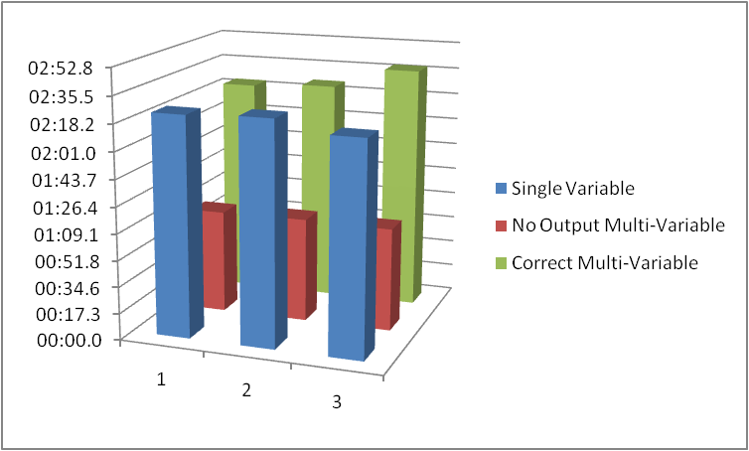

Figure - Basic Model Timing Results

These results indicate that the execution speed of a multi-variable CD++ model is directly related to the number of state variable messages that must be processed. Models that require multiple state variables that are not communicated to the cell neighborhood will experience a significant increase in processing time.

Models, like the cloud generation defined in this paper, that do require the state variables to be communicated across the cell

neighborhood do not receive the speed bonus associated with the multi-variable CD++ simulator because the number of messages associated with an update is not drastically reduced.

The multi-variable implementation was also found to perform in the same manner as the single variable implementation. As expected the basic distribution model used for this implementation did not produce realistic cloud behavior or evolution.

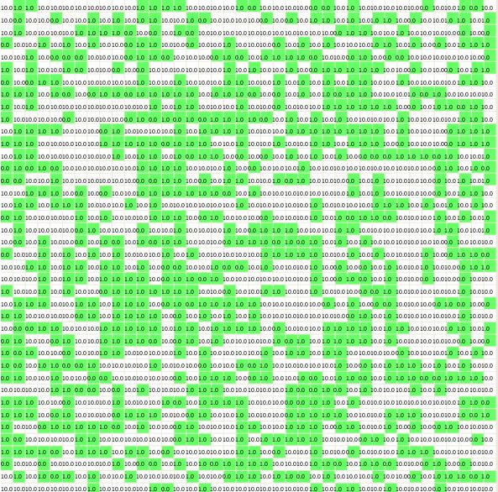

Figure - Basic Multi-Variable Visualization

## Improved Distribution Model

The improved distribution model was implemented in the multi-variable CD++. It was found that the ability to define multiple state variables made it much easier to expand a model with additional behavior. The new variable was defined and the associated transition function and macros were created. Unlike the single variable CD++ additional dimensions did not need to be added and the impact of their presence on the neighborhood and model considered.

For the results presented in this section a 20x20 cell space was run for 005:00. The distribution model was first tested to determine that diffusion of average results occurred correctly. To do this the output port used in the drawlog application was updated to reflect the appropriate average state variable. Several different average inputs were added to the event file.

00:00:00:000 dist-average-gen-one 0.5

00:00:00:100 dist-average-gen-two 0.5

00:00:00:200 dist-average-gen-three 1.0

00:00:00:300 dist-average-gen-three -0.5

Figure 10 shows the effects that multiple different average inputs will have on the average value in a cell if the input cells are close enough that the diffusion regions overlap. Figure 9 shows the effect using the input events to affect the same distribution over time. The image on the left is at 00:300 and the image at the left is at 00:400, after the effects of the new average input have been propoagated.

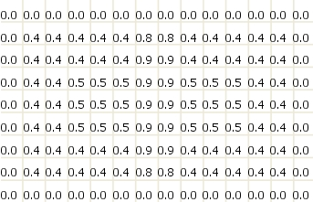

Figure - Multiple Distribution Inputs

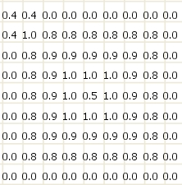 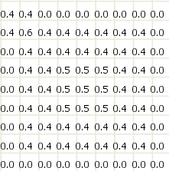

Figure - Adding Distribution Inputs

These results show that the average state variables demonstrate the desired behavior in response to inputs. The next step was to validate the effect the average state variables were having on the cloud generation behavior. This test was done in two stages, the first to test the generation of clouds and the second to test the extinction.

To test the generation of clouds the following input file was used on the cell space.

00:00:00:000 dist-average-gen-one 1.0

00:00:00:500 dist-average-gen-one -0.5

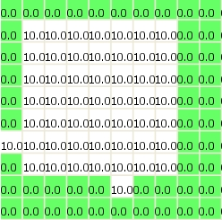 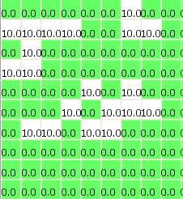

Figure – Generation Test

On the left of figure 11 is shown the state of the cloud model at 00:400, after the input of an average of 1.0 has taken effect. Clearly the presence of cloud in the region affected by this average is almost guaranteed as the generation average is greater than 0.5. The right side of figure 11 shows the system at 01:100, after the generation average has been reduced to 0.5 through the input. The generation of clouds in the system is much more random as effect of the normal distribution is more pronounced.

The second test performed on this model was on the effect of the extinction average. For this test the following input files was used:

00:00:00:000 dist-average-gen-one 1.0

00:00:00:500 dist-average-ext-one 1.0

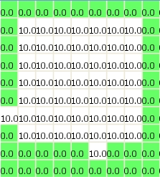 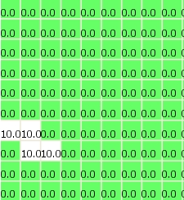

Figure - Extinction Test

On the left of figure 12 is shown the state of the cloud model at 00:400, after the input of a generation average of 1.0 has taken effect. The right side of figure 12 shows the system at 01:100, after the input of an extinction average of 1.0 has taken effect. The extinction of clouds takes priority over the generation of clouds; this explains the lack of clouds in the input region despite a generation value of 1.0. Also the effect of the extinction occurs much later than the effect of generation due to the value of 500 used for D when cloud extinction occurs.

After the correct behavior of the input distribution model was verified using the individual tests the subjective behavior of cloud generation was examined. The use of input values the changed over time for cloud extinction and generation provided a much improved manner of controlling the cloud generation behavior than was seen in the basic cloud model.

The following input values were used to generate the examples provided in figures 13 – 15.

00:00:00:000 dist-average-gen-one 0.8

00:00:00:100 dist-average-gen-two 0.3

00:00:00:200 dist-average-ext-two 0.4

00:00:00:300 dist-average-gen-three 1.0

00:00:00:400 dist-average-gen-ext 0.5

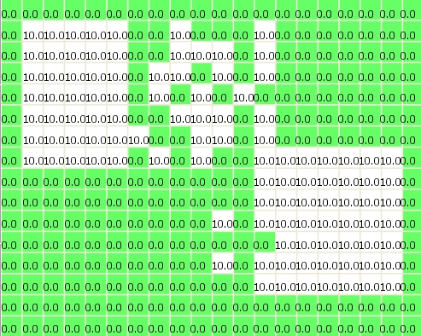

Figure - Full Distribution T=01:000

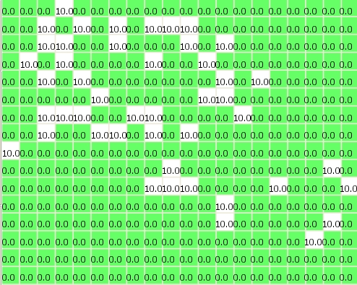

Figure - Full Distribution T=01:500

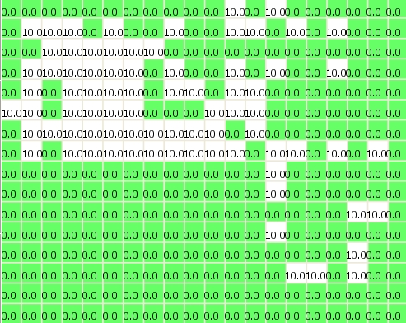

Figure - Full Distribution T=05:000

The improved distribution model allowed a much greater degree of control over where clouds where generated. However the behavior of the clouds within the simulation still left something to be desired if they were to be used as a basis for generating clouds in a visual system.

# Conclusions

What did we find out? What else can we do?

# REFERENCES

1. Dobashi, Y., Nishita, T., and Okita, T. 1998. Animation of Clouds using Cellular Automaton.
2. G. Wainer: "CD++: a Toolkit to Define Discrete-Event Models", Software, Practice and Experience, Wiley, Vol. 32, No 3. pp. 1261-1306. November 2002
3. M. Lepard: “Modelling Cloud Behaviour using Cell-DEVS”, SYSC-5104 Assignment 2. November 2009